Acoustics Exam One Report
3/20/2025

Caleb Young
Department of Science and Engineering
University of Central Arkansas
Conway AR, United State of America
cyoung24@cub.uca.edu

Abstract:

This examination aims to test our abilities to collect data in an organized error minimization fashion. This also includes testing our knowledge on high and low pass filter circuits as well as our ability to critically think/ analyze our work.
Table of Contents:

- Introduction

- Theory

- Experimental Procedure

- Results

- Discussion

- Conclusions

- References

- Introduction:

Acoustics and electronics have become very close to each other ever since we figured out how to use electronics to produce quality sound. In acoustics analog filters like the high and low pass filters are essential in this bond between the two studies. The math involved in the electronic and acoustic physics behind this exam are very similar and play off one another.

Audio signals contain frequencies ranging from low to high and in between. To produce sound properly the higher frequencies must be passed to a tweeter speaker while the low frequencies must be passed to a woofer speaker. In terms of acoustics and just physics in general, the tweeter is ideal for the high frequencies due to its ability to rapidly oscillate its diaphragm. The case is the same for the woofer, but since low frequencies out of a speaker move less air if they were the same size as the tweeter, the speaker must be larger to move air properly.

Equipment List & Setup:

ITEM | NEEDED
High Pass Filter | 1
Low Pass Filter | 1
4 Ohm Resistor | 2
4 Ohm Tweeter | 1
4 Ohm Woofer | 1
Oscilloscope | 1
Signal Generator | 1
Connecting wires | assortment
Preview image of the Cross Over Resistors setup:

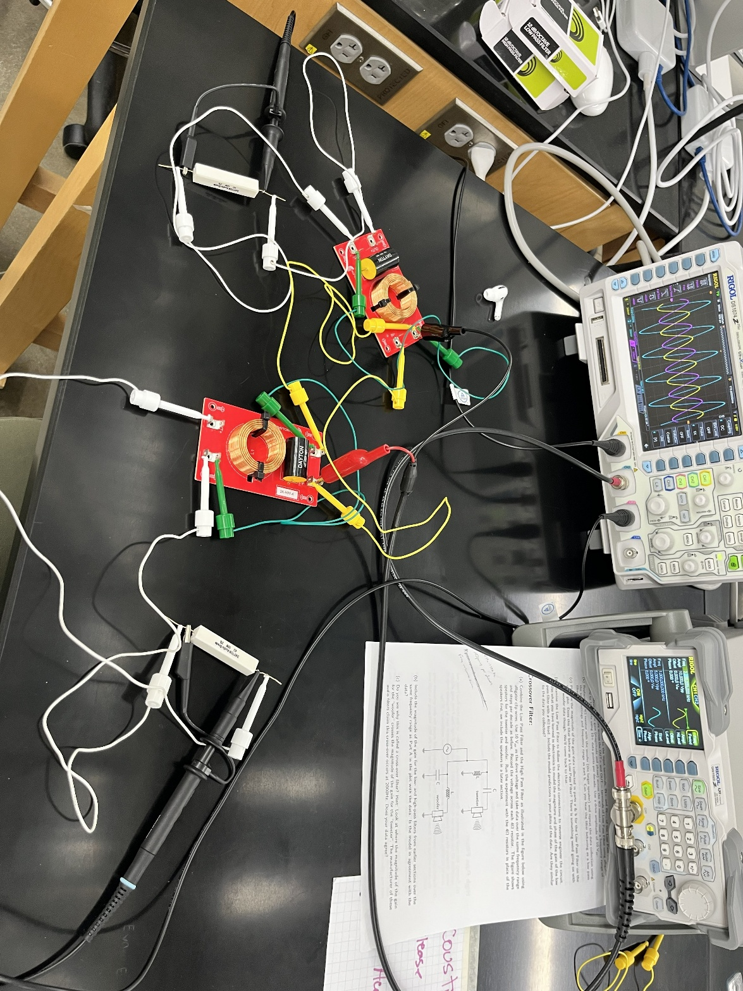

- Theory:

- Background:

- Experimental Procedure:

During the experiment, the potential difference generated when the pulse transverses the region of magnetic field will come in handy to determine the speed of the pulse on the wire for a given tension. When the pulse hits a bridge, it is inverted upon reflection and propagates back. This will cause a corresponding negative voltage generated in the coil which will be visible on the oscilloscope. Therefore, if you know the distance between the center of the coil and the bridge that caused the reflection then you can use the oscilloscope to measure the time between the pulse and its echo. The ratio of the total distance traveled and the total time gives the speed of the pulse.

Our goal is to verify that Equation 1 is correct. If we plot our experimental data as tension vs. velocity squared then the theory says the slope should be, ρL, the mass per unit length of the wire. We can experimentally and independently measure the mass per unit length by measuring the mass of a known length of the wire. A comparison of these two independent measures of ρL, with uncertainty! This will allow us to determine if Equation 1 is correct.

To perform this experiment, 2 different wires will be used. These are 26- and 46-gauge guitar strings. The results for the strings will allow for comparison. Each string is a nickel-plated steel wire wrapped around a tin-platted hex shaped steel core wire.

- Results:
Note: I made the mistake of physically writing down experiment results on paper. This caused me to waste a fair amount of time copying it into .csv files when the data should have just been recorded in them while carrying out the experiment. Please learn from this mistake of mine.

The image shown below are the on-paper resulting measurements made:
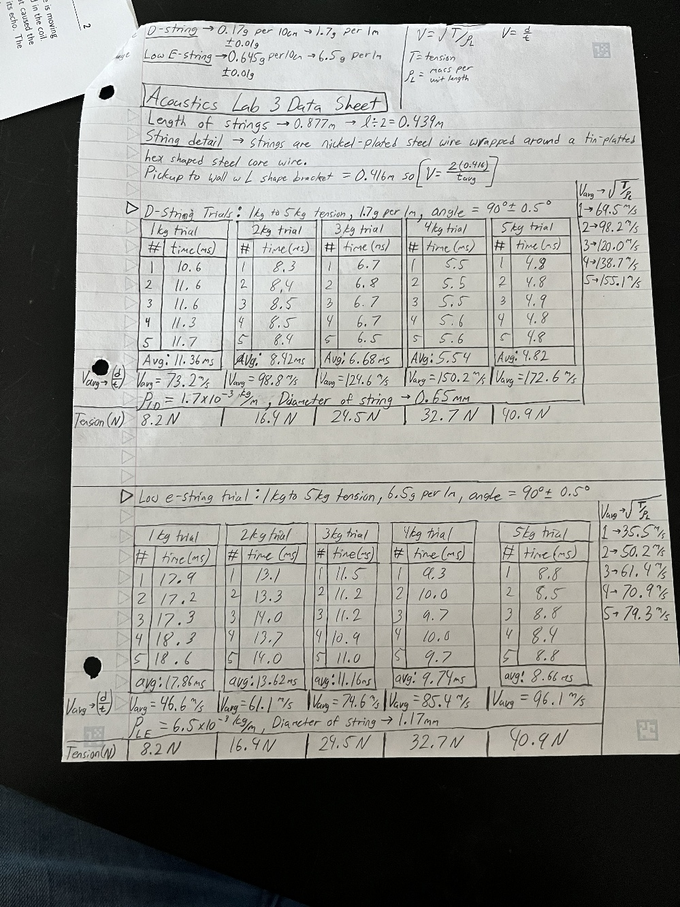
- The Initial Numbers:
My lab partner and I set the pickup roughly at the middle of the string. We measured the distance from the pickup to the wall with the L-shaped bracket to be 0.416m. The total length of the string being plucked was measured at 0.877m which means we were off center by about 23mm. There is also the vertical distance between the wire and the pickup which was measured at 6mm.

For the D-String I cut and weighed a 10cm portion of the string. After converting the measurement, I found that the D-String has a mass per unit length of:
$ρ_{LD}=\left(1.7 ±0.1\right)×{10}^{-3}\frac{kg}{m}$.
The diameter was measured at 0.65mm.

Using the same method I found the mass per unit length of the Low E-String to be:
$ρ_{LE}=(6.5 ±0.1)×{10}^{-3}\frac{kg}{m}$.
The diameter of this string was 1.17mm

Some math needed to be done to find the tension force acting on the string. This was done by using the law of sines to find angles necessary for torque equations. The torque equations were used to perform a statics problem that would give the force acting on the string in equilibrium. After completing my calculations, I determined that the tension on the strings is the same for both. These tension forces for each weight added are below:
- 1 kg 8.20N
- 2 kg 16.4N
- 3 kg 24.5N
- 4 kg 32.7N
- 5 kg 40.9N

- D-String Trials:

The D-String performed well during experimentation. We took 5 time measurements in milliseconds for each 1kg weight that was added. Below is a table containing each measured time for each trial as well as the average time. To note this is the time between the pulse echoes seen on the oscilloscope. This is the time between the wave first passing the pickup, bouncing off the wall, and then passing by the pickup again.

Measurement | Time(ms)-1kg | Time(ms)–2kg | Time(ms)-3kg | Time(ms)-4kg | Time(ms)-5kg
1 | 10.6 | 8.3 | 6.7 | 5.5 | 4.8
2 | 11.6 | 8.4 | 6.8 | 5.5 | 4.8
3 | 11.6 | 8.5 | 6.7 | 5.5 | 4.9
4 | 11.3 | 8.5 | 6.7 | 5.6 | 4.8
5 | 11.7 | 8.4 | 6.5 | 5.6 | 4.8
Avg. Time | 11.36 | 8.42 | 6.68 | 5.54 | 4.82

These average times allowed us to calculate the wave speed using distance over time. The table below will show the velocity of the wave using distance over time versus the calculated velocity using equation 1. Calculations will be in meters per second:

Calculation | Velocity-1kg | Velocity-2kg | Velocity-3kg | Velocity-4kg | Velocity-5kg
Velocity (d/t) | 73.2 | 98.8 | 124.6 | 150.2 | 172.6
Equ. 1 Velocity | 69.5 | 98.2 | 120.0 | 138.7 | 155.1
Difference | 3.7 | 0.6 | 4.6 | 11.5 | 17.5

- Low E-String Trials:

The Low E-String performed okay. On the 1kg trials we did not get very reliable data due to the weight not pulling the string tight enough. There was a good amount of rattling which caused our data to not be as clear as the D-String trials. The process is all the same and the results are below:

Measurement | Time(ms)-1kg | Time(ms)–2kg | Time(ms)-3kg | Time(ms)-4kg | Time(ms)-5kg
1 | 17.9 | 13.1 | 11.5 | 9.3 | 8.8
2 | 17.2 | 13.3 | 11.2 | 10.0 | 8.5
3 | 17.3 | 14.0 | 11.2 | 9.7 | 8.8
4 | 18.3 | 13.7 | 10.9 | 10.0 | 8.4
5 | 18.6 | 14.0 | 11.0 | 9.7 | 8.8
Avg. Time | 17.86 | 13.62 | 11.16 | 9.74 | 8.66

These average times allowed us to calculate the wave speed using distance over time. The table below will show the velocity of the wave using distance over time versus the calculated velocity using equation 1. You will notice that the differences between these velocity calculations are much greater than the D-String Trials. Calculations will be in meters per second:

Calculation | Velocity-1kg | Velocity-2kg | Velocity-3kg | Velocity-4kg | Velocity-5kg
Velocity (d/t) | 46.6 | 61.1 | 74.6 | 85.4 | 96.1
Equ. 1 Velocity | 35.5 | 50.2 | 61.4 | 70.9 | 79.3
Difference | 11.1 | 10.9 | 13.2 | 15.5 | 16.8

- Data Plotting:

These plots were done by typing my data into .csv files. Then I told CoPilot what plots and information I wanted. Once it was done I got very good looking graphs that clearly display the data that we collected. The first graph displays the tension vs velocity squared for the D-String. The second graph displays the tension vs velocity squared for the Low E-String. The third graph is something I just wanted to visualize. It is a plot of the velocity vs hanging mass for both strings.

Graph 1:
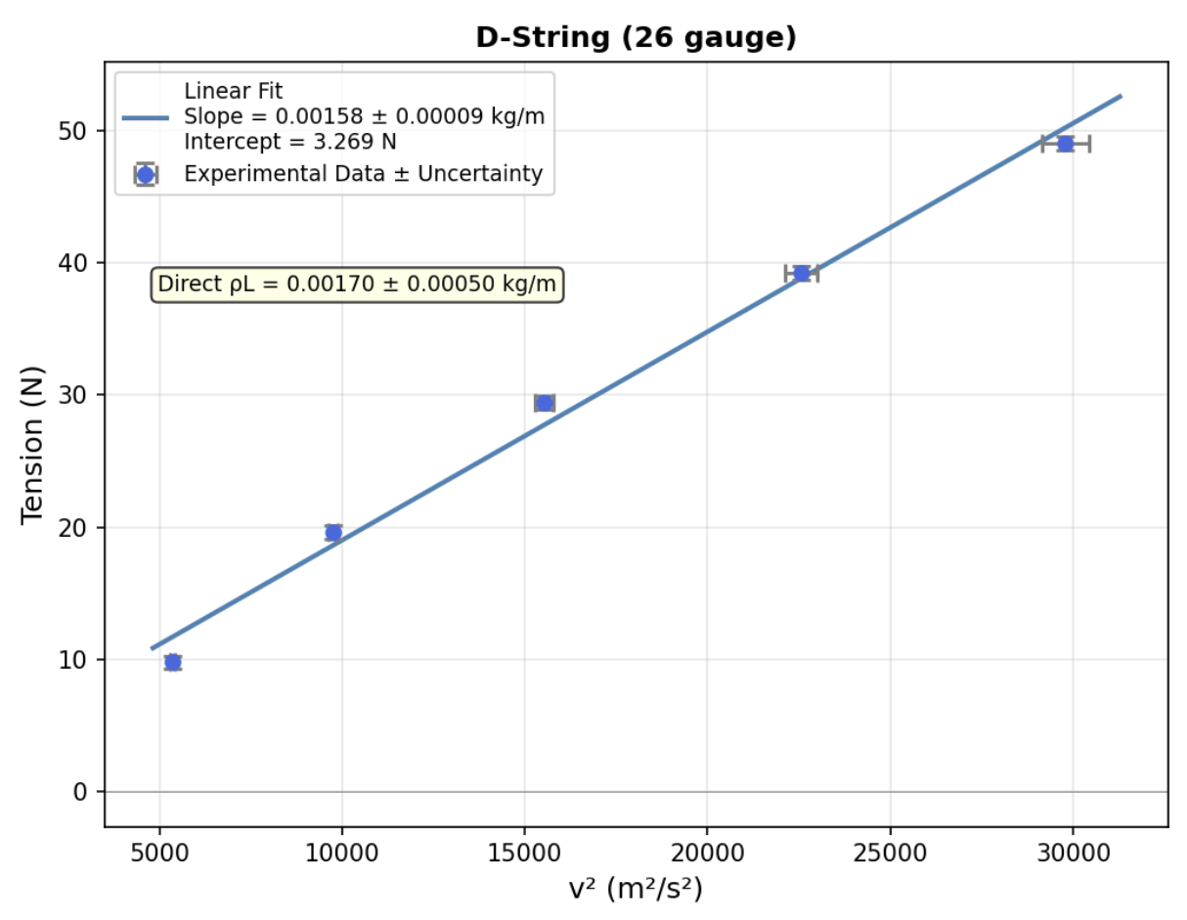

Graph 2:
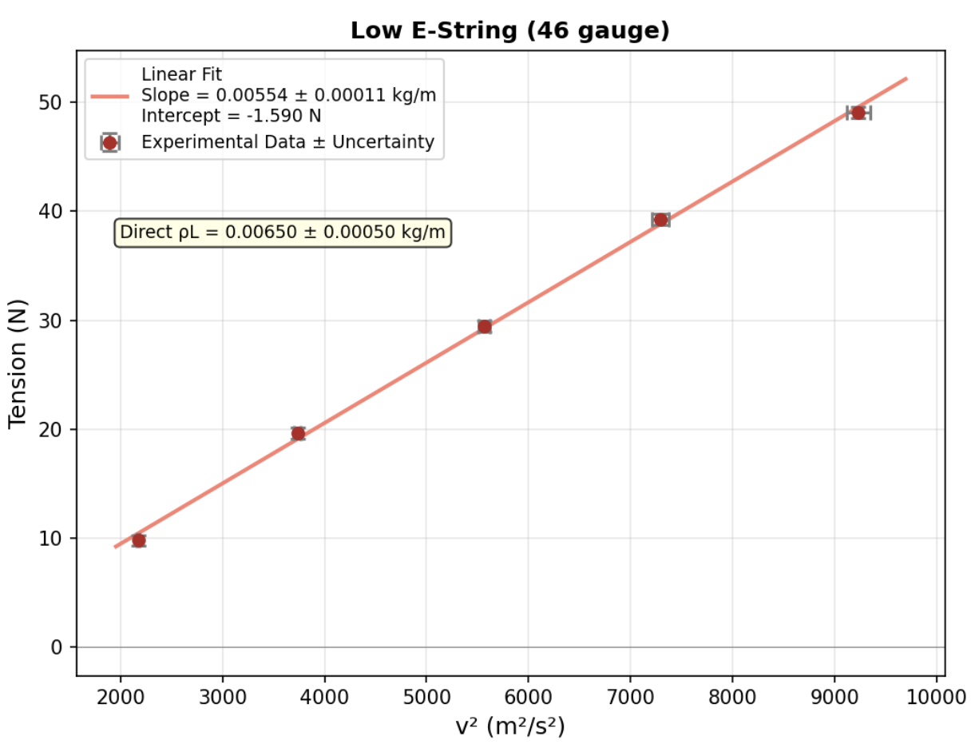

Graph 3:
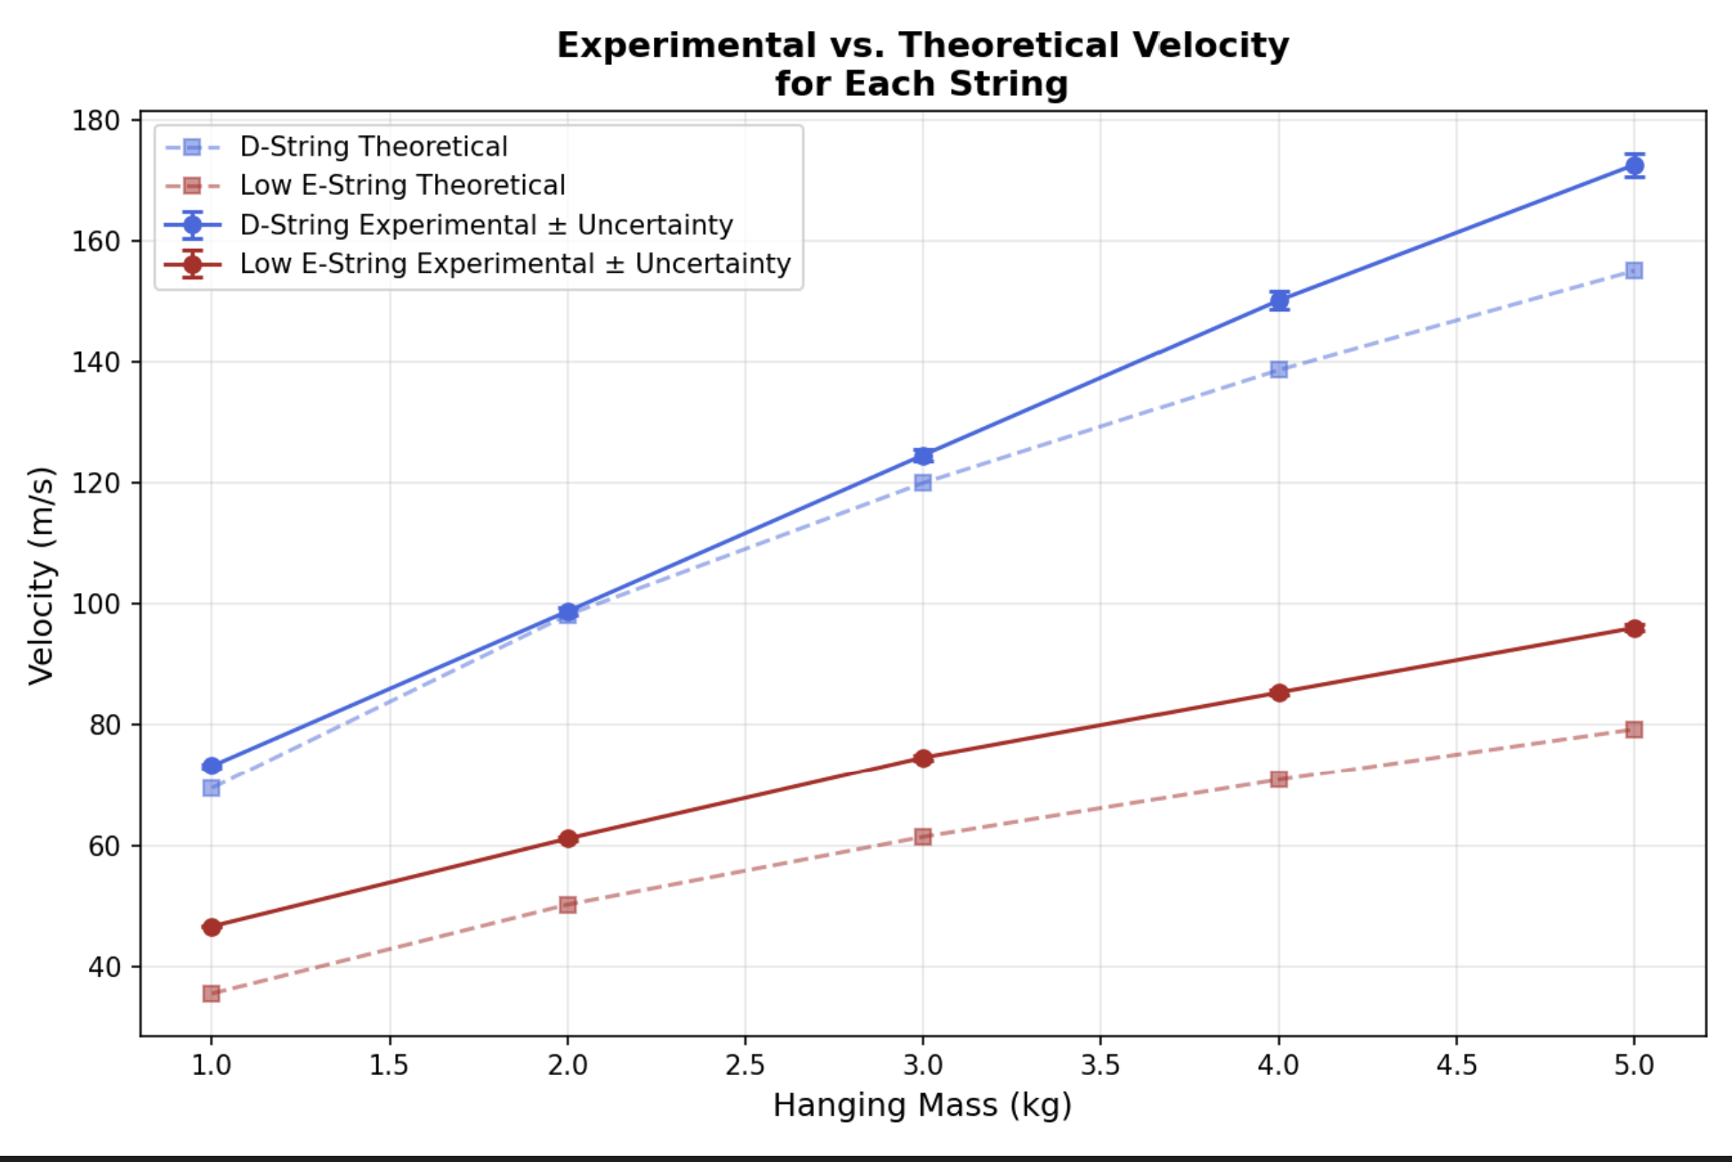

The tables below are the linear fit results for both strings:

Measurement | D-String | Low E-String
Slope (kg/m) | $$\left(157.6±8.8\right)×{10}^{-5}$$ | $$\left(554.0±11.1\right)×{10}^{-5}$$
Intercept (N) | 3.279 | -1.590
Estimated Mass per unit length (kg/m) | $$\left(170.0±10\right)×{10}^{-5}$$ | $$\left(650±10\right)×{10}^{-5}$$
Agreement Check | AGREE | DISAGREE

- Discussion:

- Overall:
This lab overall was exciting since I got to donate some of my old guitar strings to the cause. They ended up working leagues better than the regular hardware store bought steel wire initially provided.
The experiment with the Low E-String should have been done with a shorter distance and heavier weights. That string can handle more tension due to its thickness. The data collected was bad which is why the experiment didn’t pass the agreement check.

- AI-Usage:
The usage of CoPilot inside of VSCode is great. Parts of this lab in my opinion need to be done with your own personal knowledge and reasoning skills. It is important to do this during experimentation as understanding where human error occurs or could happen plays a huge role in experimentation in all areas of study. Now once you’ve collected good sufficient data and know where faults might lie, I believe it is totally reasonable to use AI in creating graphs and summarizing data. Make sure to review its results as I had to correct a few things in mine.

- Conclusions:

I do not have a grand conclusion to this lab other than knowing where I messed up with data collection. In an ideal world it wouldn’t be frustrating to erase collected to start over. During the creation of the plots I got curious as to what frequency and what note the string was producing. I created a plot of this as well which is displayed below:
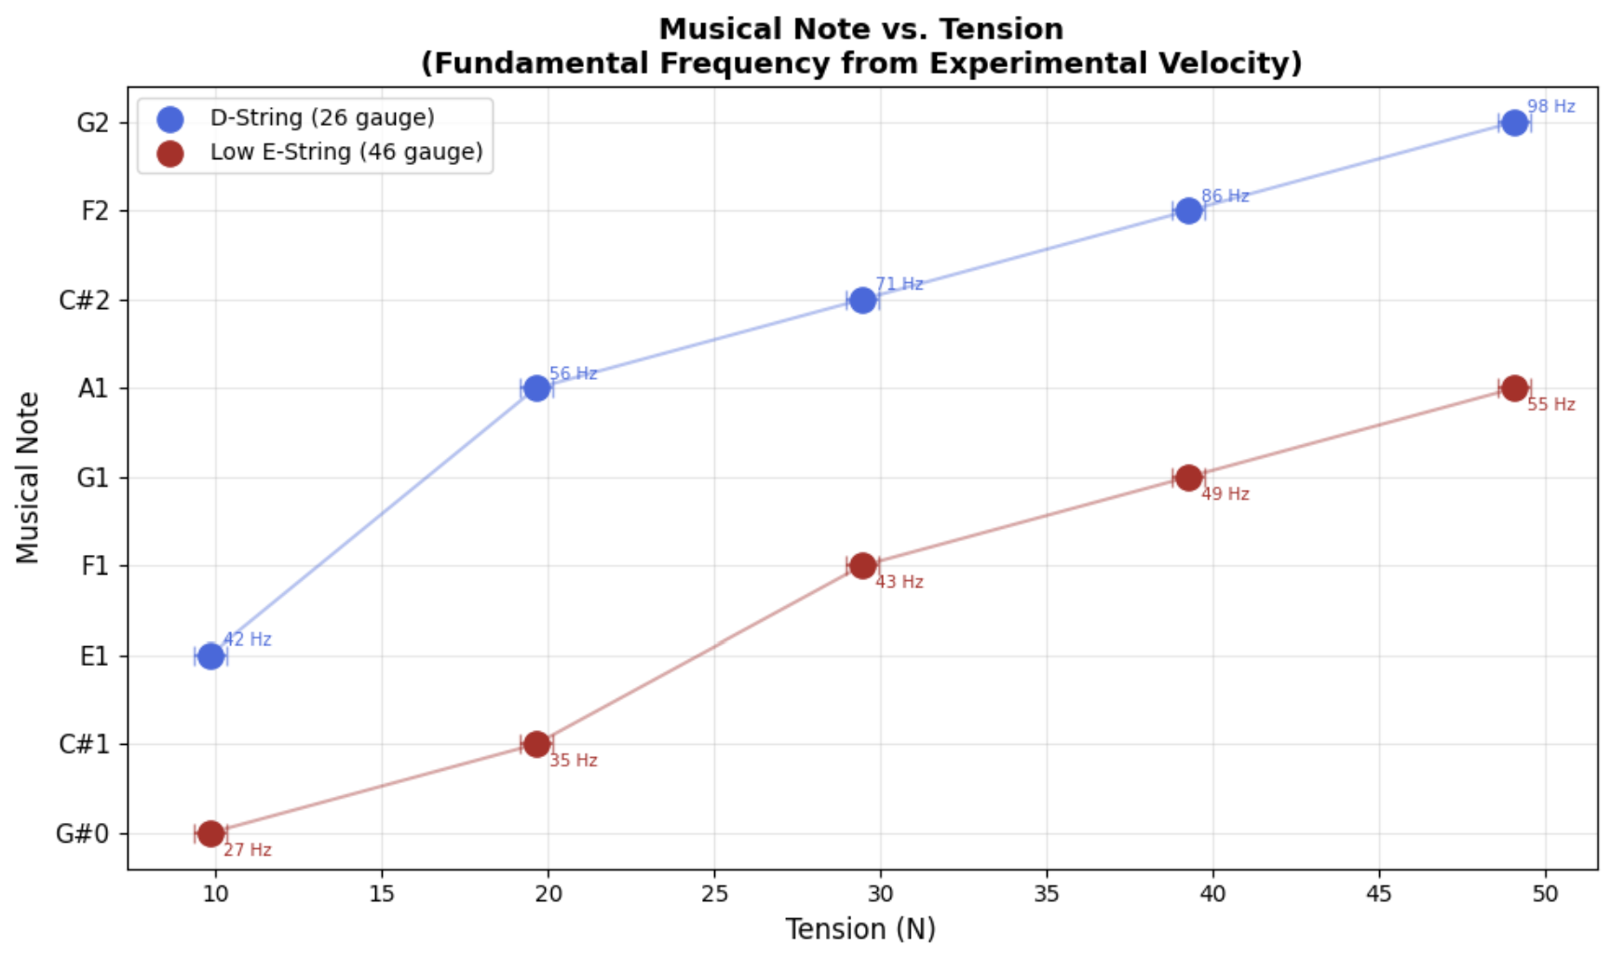

- References:

Note: I need help with proper referencing

[1] “Lab 3: Pulse on String”, Dr. Slaton Ph.D., 2026

[2] CoPilot in VSCode, Creating plots and calculations.

